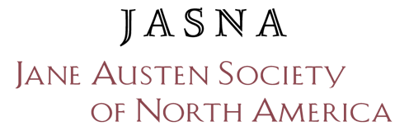
Jane Austen Book Box
Application Form

Please email this completed form to JABookBox@jasna.org.

About You and Your Organization
Your Name:
Your Email Address: Your Phone Number:
Subjects and grade levels you work with:
Your School/Organization:
Street Address:
City, State/Province, Zip/Postal Code:
School/Organization Website or Facebook Page:
School Principal/Organization Director:
Total school student enrollment or, if a library, total annual number of patrons under 18:
What percentage of the students receive free and/or reduced lunch (FRPL)?
What percentage of the students are English Language Learner (ELL)/Limited English Proficient (LEP)?
What is the socio-economic/ethnic/racial/first-language make-up of your school or organization?

About Your Project
What grade/age group would receive the books?
How do you plan to use the books? (Please be specific):

How do you plan to give away the books to the students? (Please be specific):

Which book(s) do you wish to receive in the Book Box? (Books available for this program are listed on our supplier’s website: https://www.janeaustenbooks.net/collections/jasna-jane-austen-bookbox)

How many books are needed?
What are the target start and end dates of your project?
Would you be leading this group? (Y/N): If not, please provide the leader’s name(s) here:

Reminder: All Jane Austen Book Box recipients are required to submit a written report after a project has been implemented. Please use the Grant Report form on the JASNA website. Accompanying photos and/or videos are encouraged. Signed photo/video release forms will be required for individuals in the images.
Printed Name: Date:

Signature: _________________________________________________________________________

Thank you for your application. We will respond to each completed submission.
Please email the completed form to JABookBox@jasna.org.

