The Jane Austen Society of North America

2008 Annual General Meeting – Chicago, Illinois

Austen’s Legacy: Life, Love &Laughter

_______________________________________________________________________

Legatees and heirs

1. Who were Jane Austen’s direct and immediate legatees?

Cassandra Austen Henry Austen Madame Bigeon

2. What Austen character said, “My object,…, is to be of use to those that come after me.”

Mrs. Norris and to whom was it said? Lady Bertram

3. What “was an awful legacy for a mother to bequeath” three daughters

and which mother left it? Lady Elliot

4. What was “A valuable legacy indeed!” china , plate and linen

and which mother received it? Mrs. (Mary) Dashwood

5. Whose legacy was tripled Wickham by whom Darcy

and why? So he could study law

6. Who was recorded as the heir-presumptive? William Elliot

7. Whose heir-expectant’s rights were injured Little Henry Knightley

by whom Emma and why? To marry Knightley (assuming they have children)

8. Who received the attention of idle heir-apparents? Mary Crawford
_Sister Fiction Writers/Inheritors_ 2

1. “I write only for Fame, and without any view to pecuniary emolument.”
wrote Austen to Cassandra in 1796.

2. Who wrote the following, printed in The Keepsake, and re-printed by James Austen-Leigh?
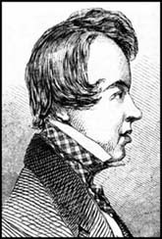
Oh Mrs. Bennet! Mrs. Norris too!
While memory survives we’ll dream of you.
And Mr. Woodhouse, whose abstemious lip
Must thin, but not too thin, his gruel sip.
Miss Bates, our idol, though the village bore;
And Mrs. Elton, ardent to explore.

While the clear style flows on without pretense,
With unsustained purity and unmatched sense,
Or if a sister e’er approached the throne,
She called the rich “inheritance” her own. George Howard, Lord Morpeth, 7th Earl Carlisle

3. Carol Shields , in her 2001 Austen biography wrote, “Jane Austen’s writing with its wit, elegance, and narrative control outshone that of her contemporaries and those Victorian novelists who came after her.”

4. P. D. James , considered Emma as a detective story in her 1998
talk at Chawton, which she appended to her fragment of an autobiography.

5. Barbara Pym , on a 1969 “visit to Jane Austen’s house”, confided to her diary, “I put my hand down on Jane’s desk and bring it up covered with dust. Oh that some of her genius might rub off on me! ”

6. Eudora Welty , in her 1969 essay wrote of Austen’s novels, “Their
spirits, their wit, their celerity and harmony of motion, their symmetry of design appear still unrivaled in the English novel. Jane Austen’s work at its best seems as nearly flawless as any fiction can be.”

7. Elizabeth Bowen , in her 1942 book on English novelists wrote of
Austen, “…as to matters of form, plot, characterisation, dialogue, setting – Jane Austen remains the most nearly flawless of English novelists.”

8. Edith Wharton , after listening to Sense and Sensibility read aloud in 1934 exclaimed, “Ah, Jane, you sorceress.” She had already written, “Jane Austen, of
course, wise in her neatness, trim in her sedateness; she never fails, but there are few or none like her.”

9. Virginia Woolf , in her 1925 Austen essay wrote, “Had she lived a few more years only … (s)he would have been the forerunner of Henry James and of Proust – but enough. Vain are these speculations: the most perfect artist among women, the writer whose books are immortal, died ‘just as she was beginning to feel confidence in her own success.’ ”
Austen Readers_ 3
In Fiction

1. In Patrick McGrath’s Trauma a psychiatrist listens to Rachmaninoff
and Elgar, and reads the life of Nietzsche and the novels of Jane Austen.

2. In Andrew Trees’ Academy X high school seniors read Emma.

3. In Karen Joy Fowler’s The Jane Austen Book Club six characters read six novels.

4. In Iris Murdoch’s Nuns and Soldiers a character reads (but never finishes)
Sense and Sensibility “with a sad quiet feeling of revisiting another period of her life …”

5. In Stella Gibbons’ Cold Comfort Farm a young woman declares she will
spend the next thirty years collecting material for a novel as good as Persuasion.

6. In Rudyard Kipling’s The Janeites a World War I veteran says, "You
take it from me, there's no one to touch Jane when you're in a tight place."

7. In Virginia Woolf’s The Voyage Out Mrs. Dalloway, onboard ship, reads
aloud the beginning of Persuasion.
•••••
In Fact
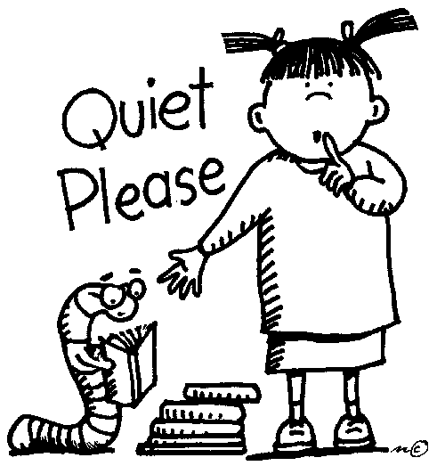
8. Nora Ephron , writer, on a newly bought couch
after her divorce, “read all of Jane Austen, six novels back to back
… in a state of suspense so intense that you would never guess I
have read them all at least ten times before.”

9. Gilbert Ryle , philosopher, devoted to Austen,
when asked if he read novels said, “Oh yes … All six, every year.”

10. Winston Churchill , statesman, commented on having
Austen read to him during World War II, “What calm lives they
led, those people! No worries about the French Revolution, or the
crashing struggle of the Napoleonic Wars! ”

11. Mark Twain/ Samuel Clemens , writer, in a 1898 letter wrote, “Every time I read Pride and
Prejudice I want to dig her up and beat her over the skull with her own shin-bone.”
12. Charles Darwin , naturalist, rested on his sofa at three each afternoon,
smoking a cigarette, and listening to a reading of Austen “or other book not scientific.”

13. George Henry Lewes , literary critic, in 1859 wrote that Austen “will doubtless be
read as long as English novels find readers…” and had begun to read Austen with
George Eliot , novelist, in 1857, after having previously urged
Charlotte Brontë , novelist, to read Pride and Prejudice and whose 1848 letter
states, “… you add, I must ‘learn to acknowledge her as one of the greatest artists, of the
greatest painters of human character, and one of the writers with the nicest sense of means
to an end that ever lived.’ ”

Inspired by Austen 4

1. Which president, in the Winter 2008 Ms. Magazine, said of women in Pride and Prejudice
and Persuasion, they “stand up to the conventions of the time, think for themselves, challenge
authority and reject anything that doesn’t fulfill their own needs.”?
Marsha Huff JASNA Pres.

2. Duma i upredzenie and Orgullo y prejuicio and Stolz und Vorurteil are translations of

Pride and Prejudice into Polish , Spanish , & German .

3. Old Friends and New Fancies , 1913, is billed as “the first Austen sequel.”

4. Name the authors of the multiple books/series described as follows:

The Mysterious Nine by Stephanie Barron

The Darcy Family Five by Elizabeth Ashton

The Diarist Heroes Five by Amanda Grange

The Mysterious Four by Carrie Bebris

The Gentleman Three by Pamela Aiden

5. Name the authors of the Jane Austen handbooks described/(sub)titled as follows:

A Reference for the Rest of Us by Joan Klingel Ray

A Heroine’s Guide to Life and Love by Patrice Hannon

A Sensible Yet Elegant Guide to Her World by Margaret Sullivan

Guide to Romance: the Regency Rules by Lauren Henderson

Guide to Good Manners by Josephine Ross

Quiz Book by Helen Barton

6. What did Deidre Le Faye, R. W. Chapman and Lord Brabourne do for Austen?

edited Austen’s letters

7. Who is the latest to complete the following:

The Watsons: Joan Aiken

Charlotte: Julia Barrett
(Sanditon)

Cinematic Austen_ 5

Match the Gentleman to the Lady

X Kate Beckinsale
C Maria Bello
Y Tracey Childs
F Jennifer Ehle
B Sabina Franklyn
Q Greer Garson
T Elizabeth Garvie
A Susannah Harker
M Anne Hathaway
R Sally Hawkins
E Felicity Jones
L Keira Knightley
D Sylvestra Le Touzel
W Hattie Morahan
N Frances O’Connor
K Maureen O’Sullivan
P Gwyneth Paltrow
Z Rosamund Pike
U Billie Piper
H Aishwarya Rai
J Irene Richard
I Amanda Root
V Alicia Silverstone
G Emma Thompson
O Charity Wakefield
S Kate Winslet
A. Crispin Bonham Carter
B. Osmond Bullock
C. Hugh Dancy
D. Nicholas Farrell
E. JJ Feild
F. Colin Firth
G. Hugh Grant
H. Martin Henderson
I. Ciaran Hinds
J. Bosco Hogan
K. Bruce Lester
L. Matthew MacFayden
M. James McAvoy
N. Jonny Lee Miller
O. David Morrissey
P. Jeremy Northam
Q. Laurence Olivier
R. Rupert Penry-Jones
S. Alan Rickman
T. David Rintoul
U. Blake Ritson
V. Paul Rudd
W. Dan Stevens
X. Mark Strong
Y. Robert Swann
Z. Simon Woods

1. How is the Nobel Prize for Literature connected to Austen on film?
Prize winner Sir Harold Pinter played Sir Thomas Bertram in “Mansfield Park”.

2. Who played 2 film Janes? Olivia Williams

3. What exactly did Aldous Huxley and Fay Weldon do for cinematic Austen?
They wrote screenplays for “Pride and Prejudice”.

4. Who went from Emma to Star Wars? Ewan Mc Gregor

5. Who are the “real life” mother and her 2 daughters who appeared in 4 Austen- related films?
Phyllida Law Emma Thompson Sophie Thompson

6. And who were their 5 characters? Mrs. Bates Miss Bates
Mrs. Austen Elinor Dashwood Mary Musgrove

The “authentic” Jane Austen ? (Circle one) 6

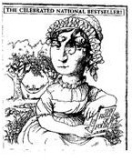
↓↓↓
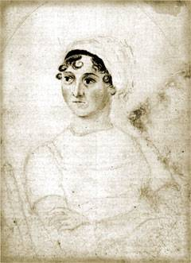
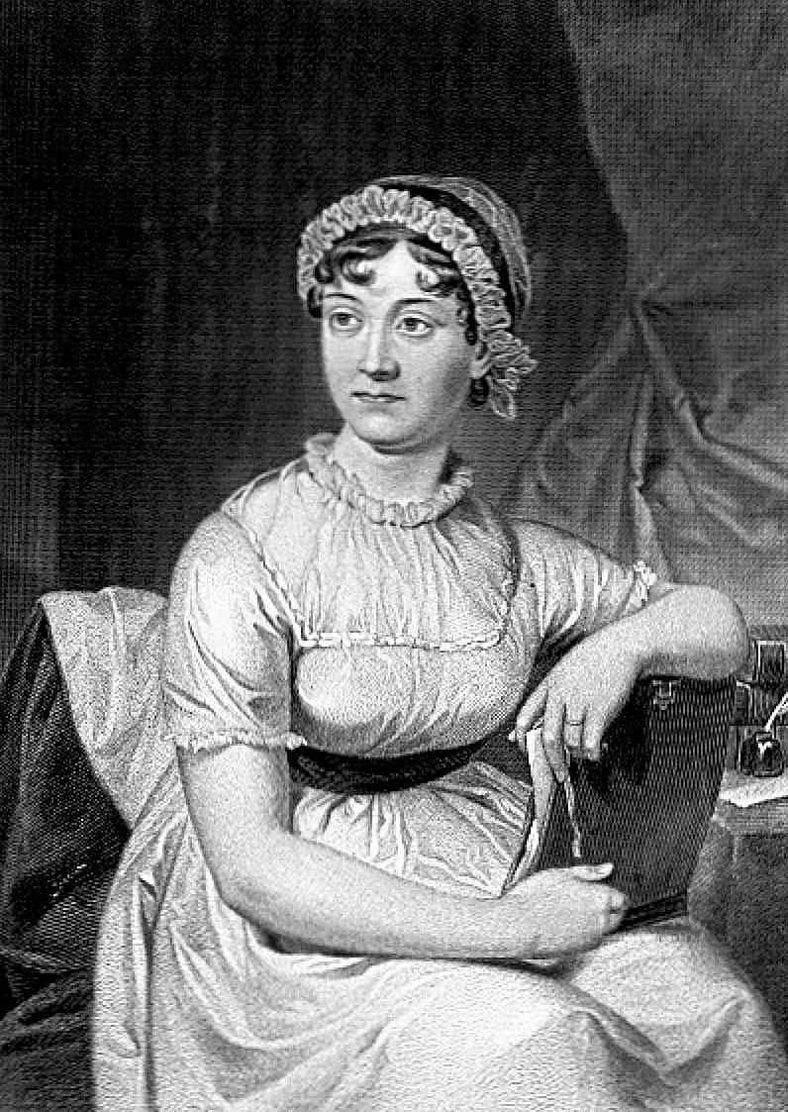
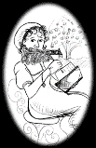

A Charade for Harriet Smith_

My first is one on which we stand,
A section, too, of a worthy race.
The rest sounds like we’re not on land,
Yet find ourselves in a briny place.

But, ah, united, with one mind,
Do Janeites meet and together dream
Of all that She has left behind,
To celebrate this Chicago theme.

What is Austen’s LEGACY ?

The Last Word

Can you find in this Quiz a word that contains all 5 vowels?

The word is abstemious (all vowels in order) or Persuasion .

__________________________________________________________________________
Quiz by Elsie Holzwarth, Greater Chicago Region, Jane Austen Society of North America

