The Jane Austen Society of North America

2008 Annual General Meeting – Chicago, Illinois

Austen’s Legacy: Life, Love &Laughter

QUIZ
_______________________________________________________________________

Legatees and heirs

1. Who were Jane Austen’s direct and immediate legatees?
__________________________ ________________________ __________________________

2. What Austen character said, “My object,…, is to be of use to those that come after me.”

_____________________________and to whom was it said?___________________________

3. What “was an awful legacy for a mother to bequeath” ______________________________

and which mother left it? ________________________________

4. What was “A valuable legacy indeed!” __________________________________________

and which mother received it? ______________________________

5. Whose legacy was tripled _________________________by whom ____________________

and why? _________________________________________

6. Who was recorded as the heir-presumptive? ______________________________________

7. Whose heir-expectant’s rights were injured ______________________________________

by whom _____________and why?

_____________________________________________

8. Who received the attention of idle heir-apparents? _________________________________

_Sister Fiction Writers/Inheritors_ 2

1. “I write only for Fame, and without any view to _________________ _________________.”
wrote Austen to Cassandra in 1796.

2. Who wrote the following, printed in The Keepsake, and re-printed by James Austen-Leigh?
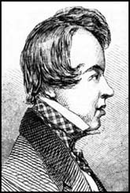
Oh Mrs. Bennet! Mrs. Norris too!
While memory survives we’ll dream of you.
And Mr. Woodhouse, whose abstemious lip
Must thin, but not too thin, his gruel sip.
Miss Bates, our idol, though the village bore;
And Mrs. Elton, ardent to explore.

While the clear style flows on without pretense,
With unsustained purity and unmatched sense,
Or if a sister e’er approached the throne,
She called the rich “inheritance” her own.
______________________________

3. ______________________________ in her 2001 Austen biography wrote, “Jane Austen’s
writing with its wit, elegance, and narrative control outshone that of her contemporaries and those Victorian novelists who came after her.”

4. ______________________________ considered Emma as a detective story in her 1998
talk at Chawton, which she appended to her fragment of an autobiography.

5. ______________________________, on a 1969 “visit to Jane Austen’s house”, confided to
her diary, “I put my hand down on Jane’s desk and bring it up covered with dust. Oh that
some of her genius might rub off on me! ”

6. ______________________________, in her 1969 essay wrote of Austen’s novels, “Their
spirits, their wit, their celerity and harmony of motion, their symmetry of design appear still
unrivaled in the English novel. Jane Austen’s work at its best seems as nearly flawless as any
fiction can be.”

7. ______________________________, in her 1942 book on English novelists wrote of
Austen, “…as to matters of form, plot, characterisation, dialogue, setting – Jane Austen
remains the most nearly flawless of English novelists.”

8. ______________________________, after listening to Sense and Sensibility read aloud in
1934 exclaimed, “Ah, Jane, you sorceress.” She had already written, “Jane Austen, of
course, wise in her neatness, trim in her sedateness; she never fails, but there are few or
none like her.”

9. ______________________________, in her 1925 Austen essay wrote, “Had she lived a few
more years only … (s)he would have been the forerunner of Henry James and of Proust – but
enough. Vain are these speculations: the most perfect artist among women, the writer whose
books are immortal, died ‘just as she was beginning to feel confidence in her own success.’ ”

Austen Readers_ 3
In Fiction

1. In Patrick McGrath’s ________________________a psychiatrist listens to Rachmaninoff
and Elgar, and reads the life of Nietzsche and the novels of Jane Austen.

2. In Andrew Trees’ ______________________________ high school seniors read Emma.

3. In Karen Joy Fowler’s ________________________________six characters read six novels.

4. In Iris Murdoch’s ______________________________ a character reads (but never finishes)
Sense and Sensibility “with a sad quiet feeling of revisiting another period of her life …”

5. In Stella Gibbons’ ______________________________ a young woman declares she will
spend the next thirty years collecting material for a novel as good as Persuasion.

6. In Rudyard Kipling’s __________________________a World War I veteran says, "You
take it from me, there's no one to touch Jane when you're in a tight place."

7. In Virginia Woolf’s __________________________ Mrs. Dalloway, onboard ship, reads
aloud the beginning of Persuasion.
•••••
In Fact
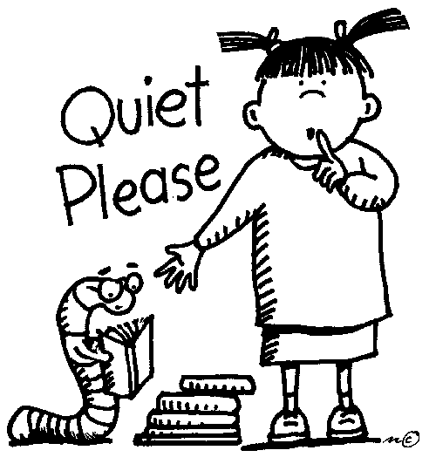
8. _________________________, writer, on a newly bought couch
after her divorce, “read all of Jane Austen, six novels back to back
… in a state of suspense so intense that you would never guess I
have read them all at least ten times before.”

9. _________________________, philosopher, devoted to Austen,
when asked if he read novels said, “Oh yes … All six, every year.”

10. _________________________, statesman, commented on having
Austen read to him during World War II, “What calm lives they
led, those people! No worries about the French Revolution, or the
crashing struggle of the Napoleonic Wars! ”

11. _________________________, writer, in a 1898 letter wrote, “Every time I read Pride and
Prejudice I want to dig her up and beat her over the skull with her own shin-bone.”
12. _________________________, naturalist, rested on his sofa at three each afternoon,
smoking a cigarette, and listening to a reading of Austen “or other book not scientific.”

13. _________________________, literary critic, in 1859 wrote that Austen “will doubtless be
read as long as English novels find readers…” and had begun to read Austen with
_________________________, novelist, in 1857 after having previously urged
_________________________, novelist, to read Pride and Prejudice and whose 1848 letter
states, “… you add, I must ‘learn to acknowledge her as one of the greatest artists, of the
greatest painters of human character, and one of the writers with the nicest sense of means
to an end that ever lived.’ ”

Inspired by Austen 4

1. Which president, in the Winter 2008 Ms. Magazine, said of women in Pride and Prejudice
and Persuasion, they “stand up to the conventions of the time, think for themselves, challenge
authority and reject anything that doesn’t fulfill their own needs.”?
______________________________________________________________________

2. Duma i upredzenie and Orgullo y prejuicio and Stolz und Vorurteil are translations of

______________________________ into ____________, ____________, & ____________.

3. _______________________________________, 1913, is billed as “the first Austen sequel.”

4. Name the authors of the multiple books/series described as follows:

The Mysterious Nine by ______________________________

The Darcy Family Five by ______________________________

The Diarist Heroes Five by ______________________________

The Mysterious Four by ______________________________

The Gentleman Three by ______________________________

5. Name the authors of the Jane Austen handbooks described/(sub)titled as follows:

A Reference for the Rest of Us by _______________________________

A Heroine’s Guide to Life and Love by _______________________________

A Sensible Yet Elegant Guide to Her World by _______________________________

Guide to Romance: the Regency Rules by _______________________________

Guide to Good Manners by _______________________________

Quiz Book by _______________________________

6. What did Deidre Le Faye, R. W. Chapman and Lord Brabourne do for Austen?

_______________________________________________________

7. Who is the latest to complete the following:

The Watsons: _______________________________

Charlotte: _______________________________
(Sanditon)

Cinematic Austen_ 5

Match the Gentleman to the Lady

___ Kate Beckinsale
___ Maria Bello
___ Tracey Childs
___ Jennifer Ehle
___ Sabina Franklyn
___ Greer Garson
___ Elizabeth Garvie
___ Susannah Harker
___ Anne Hathaway
___ Sally Hawkins
___ Felicity Jones
___ Keira Knightley
___ Sylvestra Le Touzel
___ Hattie Morahan
___ Frances O’Connor
___ Maureen O’Sullivan
___ Gwyneth Paltrow
___ Rosamund Pike
___ Billie Piper
___ Aishwarya Rai
___ Irene Richard
___ Amanda Root
___ Alicia Silverstone
___ Emma Thompson
___ Charity Wakefield
___ Kate Winslet
A. Crispin Bonham Carter
B. Osmond Bullock
C. Hugh Dancy
D. Nicholas Farrell
E. JJ Feild
F. Colin Firth
G. Hugh Grant
H. Martin Henderson
I. Ciaran Hinds
J. Bosco Hogan
K. Bruce Lester
L. Matthew MacFayden
M. James McAvoy
N. Jonny Lee Miller
O. David Morrissey
P. Jeremy Northam
Q. Laurence Olivier
R. Rupert Penry-Jones
S. Alan Rickman
T. David Rintoul
U. Blake Ritson
V. Paul Rudd
W. Dan Stevens
X. Mark Strong
Y. Robert Swann
Z. Simon Woods

1. How is the Nobel Prize for Literature connected to Austen on film?

______________________________________________________________________________

2. Who played 2 film Janes? ____________________________

3. What exactly did Aldous Huxley and Fay Weldon do for cinematic Austen?

______________________________________________________________________________

4. Who went from Emma to Star Wars? ______________________________

5. Who are the “real life” mother and her 2 daughters who appeared in 4 Austen-related films?

________________________ _______________________ ________________________

6. And who were their 5 characters? _____________________ _______________________

________________________ ________________________ ________________________

The “authentic” Jane Austen ? (Circle one) 6

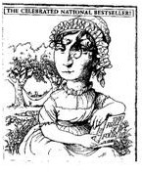
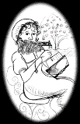
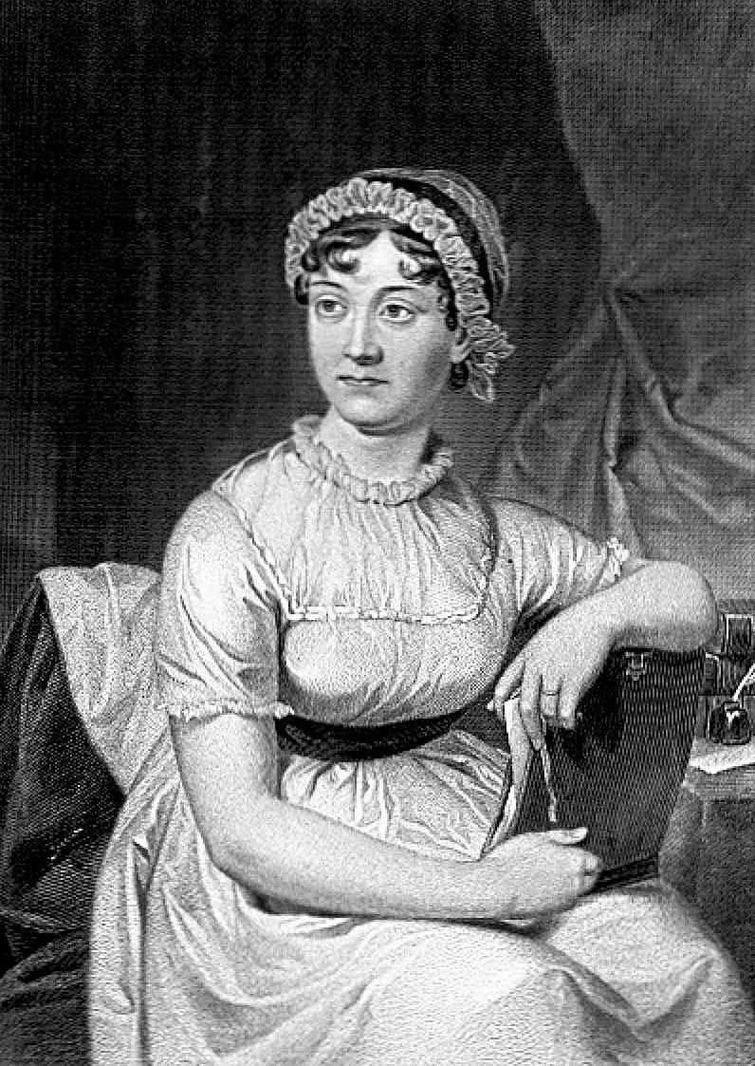
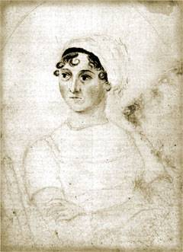

A Charade for Harriet Smith_

My first is one on which we stand,
A section, too, of a worthy race.
The rest sounds like we’re not on land,
Yet find ourselves in a briny place.

But, ah, united, with one mind,
Do Janeites meet and together dream
Of all that She has left behind,
To celebrate this Chicago theme.

What is Austen’s ______________________?

The Last Word

Can you find in this Quiz a word that contains all 5 vowels?

The word is _________________________.

__________________________________________________________________________
Quiz by Elsie Holzwarth, Greater Chicago Region, Jane Austen Society of North America

