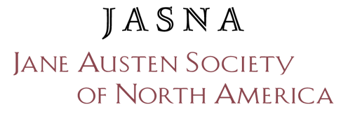

JASNA International Visitor Program
2024 Application Form

In addition to this form, please provide the following:

1) A copy of your CV or résumé.

2) A sample of your work. If your work is lengthy, please provide the committee an excerpt of no more than 5 pages (or the equivalent for creative pieces). Please note that work samples will not be returned to applicants.

Send the completed application and supporting materials by email to chawtonivp@jasna.org OR mail to:

Carol Chernega
202 Truxall Road
Apollo, PA 15613

ALL COMPLETE APPLICATIONS MUST BE RECEIVED BY DECEMBER 16, 2023.

- Incomplete applications will not be considered.
- Do not send unsolicited materials with your application—the committee will contact you and/or your references if we have questions about your application.

Please type in all information, as handwriting is difficult to read.

Background Information
Name
Street Address
City & State/Province
Zip/Post Code
Country
Home Phone
Alternative Phone
E-Mail Address

Are you a current JASNA member? ___Yes ___No

Professional Status
Check all applicable categories:
 | Student |  | Retired
 | Teacher/Professor |  | Other (please specify)
Name and address of your institution and/or your employer (if applicable).

Professional Reference(s)
Please provide the following information for 1-3 professional and/or JASNA references who can speak to your ability to complete the proposed project: name, e-mail address, street address, telephone number, and title.

Describe Your Research Project
My project involves:
 | Visual Art |  | Writing
 | Performing Art |  | Other (please specify)
 | Research |  | ______________________________
Briefly (in a sentence or two) describe your project.

Please list the work (if any) that you have already completed on this project. In particular, the committee is interested to know what research sources readily available in the United States and Canada applicants have already exhausted.

 | Project Detail
I will work at/with:
 |  | Chawton House |  | Jane Austen’s House |  | St. Nicholas Church

In no more than 750 words, describe what you hope to accomplish during the International Visitor Program period. Provide specific details about your proposed project, including a discussion of the specific resources at your selected site(s), and how they will assist you in completing your project.

State the anticipated product(s) of your work at Chawton:

Briefly (in a sentence or two) describe the audience(s) for your work, and how you can ensure your work reaches them. Keep in mind that the committee is particularly interested in projects that will reach a JASNA audience and/or introduce new audiences to JASNA:

Project Skills
Please identify the skills that you will bring to Jane Austen’s House, Chawton House, and St. Nicholas Church.

Agreement and Signature
By submitting this application, I affirm that the facts set forth in it are true and complete. I understand that any false statement, omission of relevant information, or other misrepresentation made by me may result in my disqualification for the International Visitor Program.

If selected to be JASNA's International Visitor, I will comply with all rules set forth in the International Visitor Program application materials, including, but not limited to, the requirement regarding on-site work in England during July and August 2024.

Date
Name (printed)
Signature

